**Exercise 2: Implementing Dependency Injection**

**Scenario:**

In the library management application, you need to manage the dependencies between the BookService and BookRepository classes using Spring's IoC and DI.

**SOLUTION:**

**applicationContext.xml**

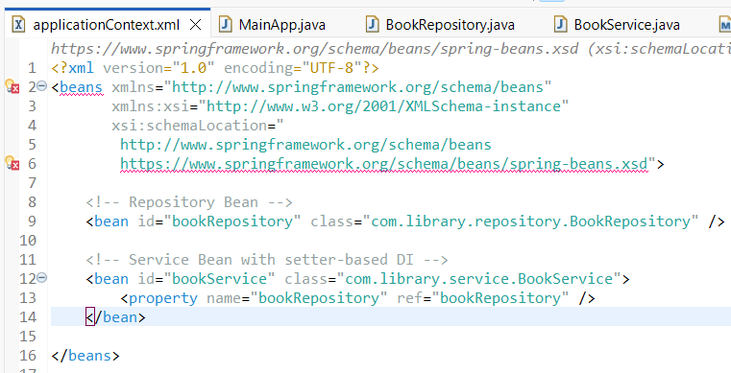

**BookService.java**

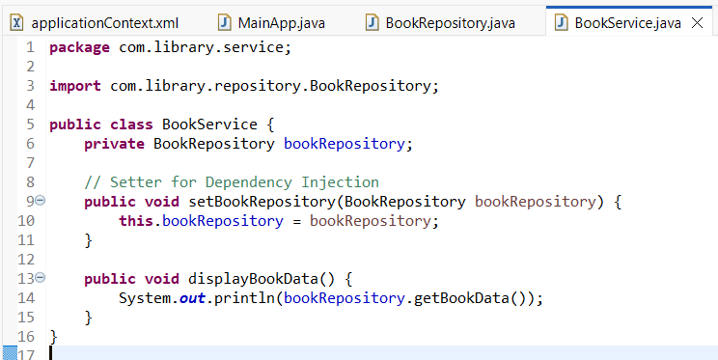

**BookRepository.java**

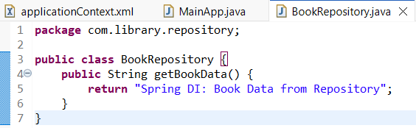

**OUTPUT:**

